Details about the demonstration
- instructions.sh
  - Shows the instructions to be taken for the demonstration
- wsl_setup.sh
  - Set up the network namespaces and allow connection with one another using a virtual bridge
  - A bridge acts as a virtual switch by allowing virtual LANs to be combined to a single virtual LAN
  - Set up virtual ethernet pairs
    - For each namespace, use ip link to add connections, one end goes to the namespace and the other one goes to the bridge
  - IP addresses
    - Virtual bridge (br0): 192.168.1.254
    - Gateway: 192.168.201.1
    - Victim: 192.168.201.10
    - Attacker: 192.168.20.20
  - Interface activation, brings up virtual interfaces
  - Routing configuration
    - Add the routing for the namespaces using ip route add
    - For the victim and the attacker, by default route it to the gateway
    - For the gateway, route it to the virtual bridge
  - Enable ip forwarding for the gateway
    - Essential for gateway set ups so that the ip packets can be forwarded from one namespace to another.
  - NAT configuration
    - Clear the ip tables rules and add NAT rules to the ip tables.
    - POSTROUTING is for packets that are about to leave the system ie going out to the internet.
    - MASQUERADE is used to tell the ip table to change the source IP address of the outgoing packets to match the IP address of the outgoing interface.
    - The NAT tule that is being added to the ip tables is for the packets that are leaving the name space, their ip addresses to be changed to the IP address of the outgoing interface.
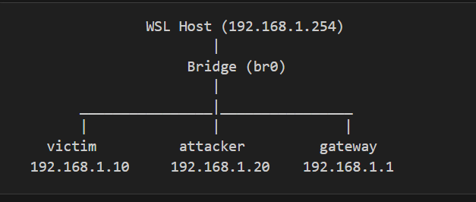
  - Verification
    - Check the connectivity between the network interfaces.
- Verify_connectivity.py
  - run_cmd
    - Executes shell commands and provides formatted output
  - check_wsl_environment
    - Check if the program is running on WSL
  - test_namespace_connectivity(ns_name)
    - Test the network namespace connectivity individually
    - ip netns exec {ns_name} ip addr show
    - ip netns exec {ns_name} ip link show
      - Shows the interface name and states
      - Ip address
      - Mac addresses
      - MTU settings and link type
    - ip netns exec {ns_name} ip route show
      - Shows network routes
      - Connected routes
      - Routing metrics
      - Default gateway
    - timeout 5 ip netns exec {ns_name} ping -c 2 -W 2 192.168.201.1
      - Pings the gateway
    - Timeout 5 ip netns exec {ns_name} ping -c -W 2 8.8.8.8
      - Pings the internet
    - Ip netns exec {ns_name} ping -c 1 -W 2 google.con
      - Test to see if the DNS resolution is working
      - Verifies ability to resolve domain names
- monitor.sh
  - Pane 0
    - Monitors the victim’s routing table
    - Continuously monitors the routing table of the victim’s namespace, checking routes to the target (8.8.8.8)
    - The color of the traffic will change if there is a change in the routing table.
    - Make use of sudo ip netns to view the routing table of the victim
  - Pane 1
    - Shows the static Network Topology graph
  - Pane 2
    - Make us e of tcpdump to monitor ICMP traffic in the victim namespace
    - Shows the ICMP redirect, echo requests and echo replies.
    - Color coded to show the highlight of the attack related messages
  - Pane 3
    - Pane monitors all traffic from the attacker namespace.
  - Pane 4
    - Continuously pings 8.8.8.8 from the victim namespace, displaying the results in green for successful pings
  - Pane 5
    - Showcase the life updates of the attack script
    - Showcase the life results of the attack, whether it is being blocked or the attack went through
- icmp_redirect_attack.py
  - Launch the ICMP redirect attack
  - Crafts the ICMP packets
    - Source ip is set to the gateway’s ip
    - Destination IP set to the victim’s ip
    - ICMP type set to 5 for the redirect
    - Gateway is set to the attacker’s ip where the traffic will be redirected
  - Prepare the attack
    - Flushes the routing cache of the victim
    - Deletes any existing route to the target via the attacker
    - Sets the default route for the victim to the legitimate gateway
    - Ensures IP forwarding is enabled to the attacker
  - Main attack loop
    - Actively sends the redirect message to the victim.
    - Checks if there is any changes in the routing table of the victim. If yes, the attack is considered successful otherwise it will be blocked.
- mitigation.sh
  - Manages the ICMP redirect attack mitigations
  - Able to make the victim vulnerable or protected.
  - Change the victim’s kernel parameters
    - Using sysctl -w
    - Allows us to modify the kernel parameters
  - Flushes any ip routing rules and modify them to allow ICMP redirect attacks
  - Reset the routing in the name space
- Thorough_cleanup.sh
  - Used to thoroughly clean up all the network namespaces and any changes to the system’s network configurations during the attack.
  - Use tools like ip link del
  - sudo iptables -F

